PRT661

Energy Demand Forecasting System
Data Acquisition and File Management

Purpose: provide a reproducible and understandable record of how project data is acquired, organised, validated and prepared for the later forecasting pipeline.

Document Control
Item | Description
Primary implementation file | Data_Acquisition final.py
Primary acquisition sources | AEMO NEM/WEM sources, AEMO dashboard API, Bureau of Meteorology data and Australian public-holiday calendars
Default acquisition start | 2022-01-01
Default acquisition end | Current date at runtime
Demand regions | NSW1, QLD1, VIC1, SA1, TAS1, WA
Feature regions in current script | NSW1, QLD1, VIC1, SA1, TAS1, WA, NT (NT features only; no NT demand file)
Primary raw folders | price_and_demand, energy_requirement, dispatch, predispatch, bom_weather, public_holidays

Executive Summary
The PRT661 Energy Demand Forecasting project uses a multi-source data pipeline to collect electricity demand and market information together with weather and public-holiday drivers. The objective of this design is to create a defensible raw-data foundation for later forecasting, rather than mixing downloading, manual editing, preprocessing and modelling in a single step.
The acquisition program retrieves historical NEM price-and-demand files, constructs a combined WA/SWIS operational-demand history, downloads a separate 2026 WA market-requirements file, captures current NEM dispatch and pre-dispatch snapshots, obtains daily BOM weather variables, and generates state-specific public-holiday calendars. Each output is written to a dedicated folder so that the raw layer remains understandable and auditable.
A key engineering decision is the preservation of WA source frequency. Legacy WA demand uses 30-minute observations through September 2023, while newer WEM data uses 5-minute observations from October 2023. The acquisition program preserves this distinction and records SOURCE_INTERVAL_MIN instead of inventing 5-minute historical values. A later preprocessing stage should harmonise the data to a modelling frequency that does not create artificial observations.
The recommended architecture separates raw, interim and processed data. Raw files remain unchanged evidence; interim files contain validated and harmonised tables; processed files contain feature-engineered datasets ready for forecasting. This separation improves reproducibility, reduces accidental data corruption and makes the final analytical workflow easier to explain and test.

1. Purpose and Scope
This document records the full data-handling process surrounding the current PRT661 acquisition pipeline. It explains where the data comes from, how the Python program retrieves it, how files are organised, what quality controls are already applied during ingestion, and how the raw outputs should be transformed in the next preprocessing stage.

1.1 Objectives
- Create a repeatable data-acquisition workflow for electricity-demand forecasting.
- Keep raw source data separated by purpose and region so that files remain easy to trace.
- Preserve source-specific characteristics, particularly WA interval frequency and data provenance.
- Provide enough validation during ingestion to prevent obvious malformed or duplicate records from silently propagating.
- Define a clear boundary between raw acquisition and modelling preprocessing.
- Establish a data-management structure that can support later model training, validation and dashboard reporting.

2. End-to-End Pipeline Architecture
The project is best understood as a sequence of controlled layers. External sources are first ingested into a raw directory. Validation and preprocessing then convert those raw outputs into harmonised intermediate data. Feature engineering creates modelling-ready tables, after which forecasting, evaluation and dashboard reporting are performed.
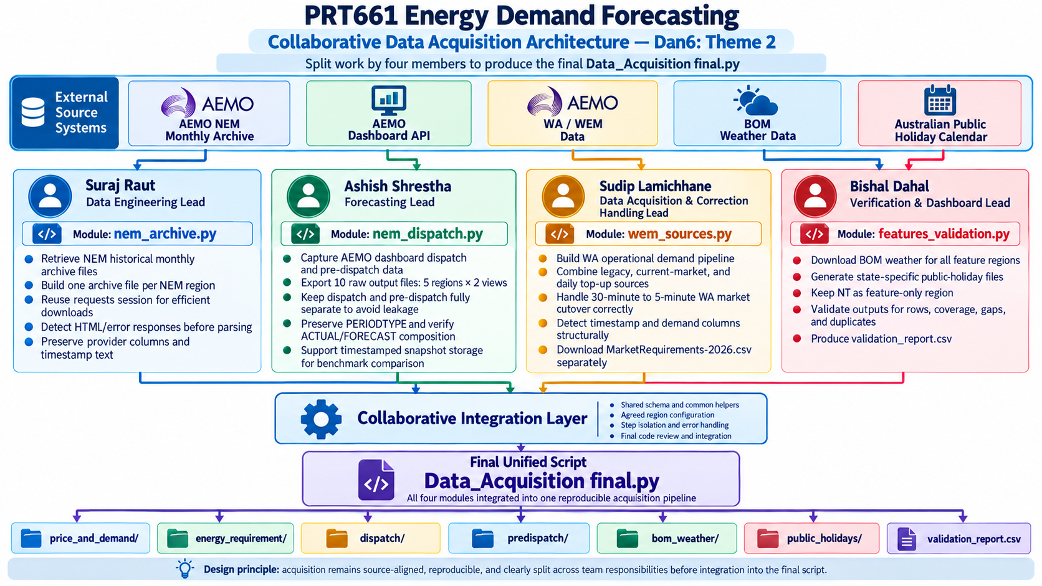

Figure 1. End-to-end architecture for the PRT661 forecasting pipeline.

3. File Management Strategy
The current raw directory already separates files by function. This should be retained and extended into a three-layer data structure: raw, interim and processed. This design prevents source files from being overwritten during experimentation and makes every modelling dataset reproducible from the original acquisition outputs.

4. Region and Source Configuration
The Python file differentiates demand regions from feature regions. Historical demand is available for the five NEM regions plus WA. The current implementation also collects NT weather and holiday features even though it does not acquire an NT demand series.

4.1 Source Categories
Source | Data obtained | Purpose in forecasting
AEMO monthly NEM archive | Price and demand history by NEM region | Historical target series and market context
AEMO WEM/WA files | WA operational demand at native source intervals | WA historical target series
AEMO dashboard API | Dispatch (5MIN) and pre-dispatch (30MIN) snapshots | Current operating state and short-horizon benchmark/context
AEMO WA market-requirements CSV | MarketRequirements-2026.csv | Separate 2026 WA market information
Bureau of Meteorology | Daily max temperature, min temperature and rainfall | Weather drivers
Australian holiday calendars | Daily holiday indicator and holiday name by state | Behavioural/calendar drivers

5. Data Acquisition Workflow
The main routine executes acquisition steps in a deliberate order. Dashboard snapshots are requested first because they represent a short rolling window and may not be recoverable later. Historical archives are more persistent and can be retried. Each step runs inside an isolation wrapper so a failed source is logged without preventing later stages from executing.

5.1 Output Directory Selection and Initialisation
If no output directory is supplied, the script attempts to open a graphical folder-selection dialog. If a graphical environment is unavailable, it falls back to a typed path, with ./data/raw as the final default. The program then creates the expected subdirectories and writes DATA_NOTES.md before acquisition begins.

5.2 Dispatch and Pre-dispatch Snapshots
AEMO dashboard data is requested from a single API endpoint using different time-scale payloads. Dispatch uses 5MIN and pre-dispatch uses 30MIN. The API returns multiple regions in one response; the script splits the result by REGIONID and writes one CSV per NEM region. Columns are kept in the order returned by AEMO, and each run overwrites the current snapshot unless timestamped snapshot archiving is explicitly enabled.
View | Time scale | Expected files | Acquisition behaviour
Dispatch | 5 minutes | dispatch_NSW1.csv … dispatch_TAS1.csv | Current snapshot, split by REGIONID
Pre-dispatch | 30 minutes | predispatch_NSW1.csv … predispatch_TAS1.csv | Current snapshot, split by REGIONID

5.3 WA/SWIS Operational Demand
WA requires a separate pipeline because WEM source structures and interval frequencies differ from the NEM archive. The acquisition program identifies the most plausible timestamp and operational-demand columns, normalises the result to a common WA schema, and records the source name and native interval for every row.
Period | Native source interval | Handling
1 Jan 2022 – 30 Sep 2023 | 30 minutes | Legacy WEM operational-demand observations retained at native frequency
From 1 Oct 2023 | 5 minutes | Modern WEM operational-demand observations retained at native frequency
Recent current-year tail | 5 minutes where available | Daily files can top up lagging annual data, capped by wa-tail-days

5.4 WA 2026 Market Requirements
Market Requirements-2026.csv is downloaded separately from operational demand and written unchanged to the energy_requirement folder. Keeping this file separate avoids confusing a market-requirements dataset with observed demand. Its variables can later be assessed for validation, contextual analysis or feature use, depending on the final modelling design.

5.5 BOM Weather Acquisition
For each feature region, the program uses a configured BOM station and requests three daily products: maximum temperature, minimum temperature and rainfall. Each variable is stored in a separate CSV so that the raw response remains easy to trace to its source and station.
- Maximum temperature – product code 122
- Minimum temperature – product code 123
- Rainfall – product code 136
During preprocessing, these separate daily files should be standardised and merged into a regional weather table keyed by local date and region.

5.7 Public-Holiday Calendars
The public-holiday stage generates one daily calendar per region/state across the requested date range. Each file contains the date, a binary public-holiday indicator and the holiday name. This creates reproducible calendar features without manually maintaining holiday spreadsheets.
Field | Meaning
date | Calendar date across the requested range
is_public_holiday | 1 when the date is a public holiday for the state; otherwise 0
holiday_name | Name returned by the holiday calendar when applicable

5.8 Step Isolation and Logging
Each acquisition activity is executed through a run_step wrapper. Exceptions are caught and written to the log, and the pipeline continues. This is important because external sources can be temporarily unavailable, malformed or slow. One failed download should not discard data successfully available from the other sources.

6. Dataset Inventory and Evidence
The following screenshots document the current output structure produced during acquisition. They are useful as implementation evidence because they show that the acquisition logic creates separate folders and region-specific outputs rather than a single unmanaged data dump.
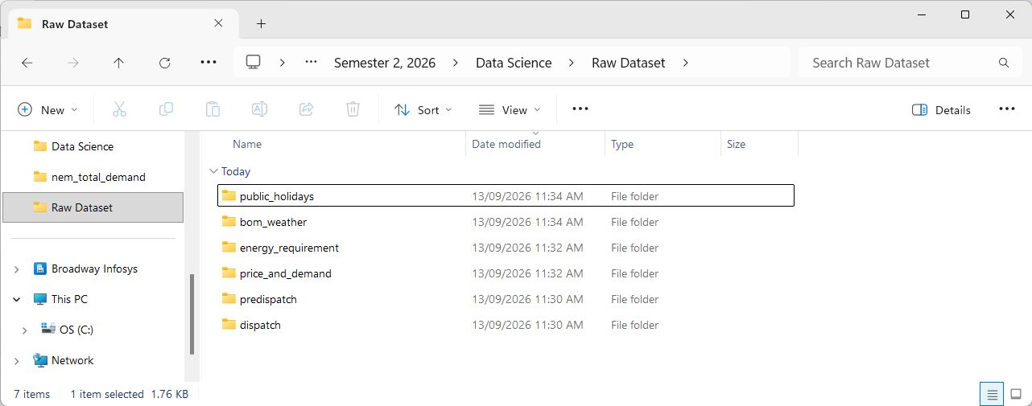
Figure 3. Current Raw Dataset directory showing the six acquisition categories.
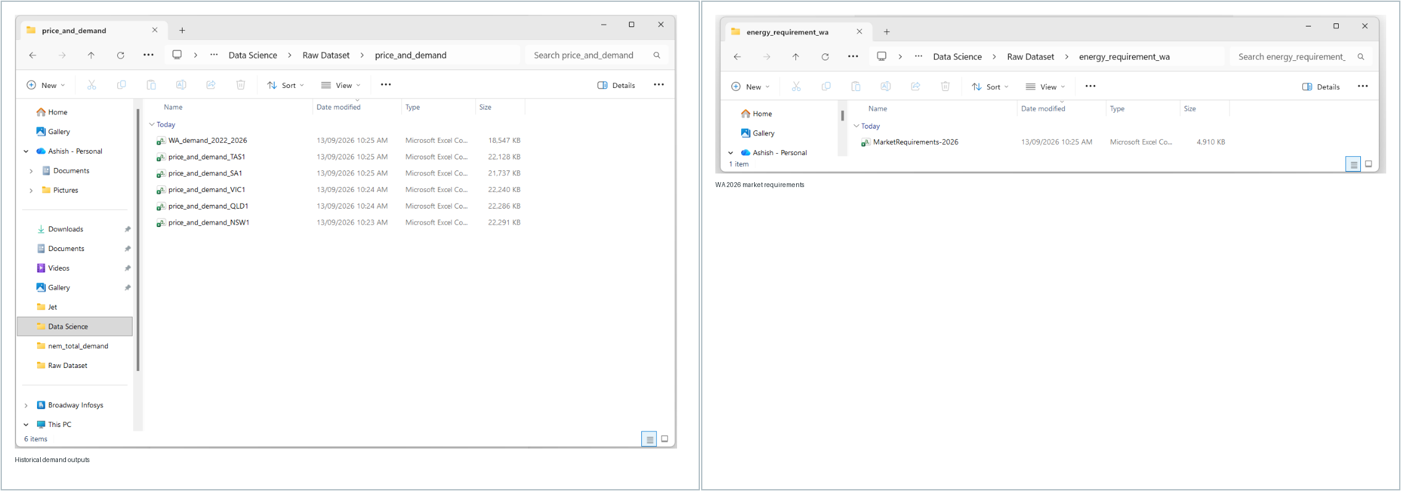
Figure 4. Historical price-and-demand outputs and the separate WA 2026 market-requirements file.
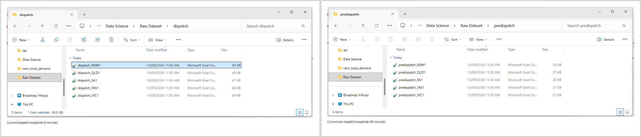
Figure 5. Region-specific dispatch and pre-dispatch snapshots produced from the AEMO dashboard API.
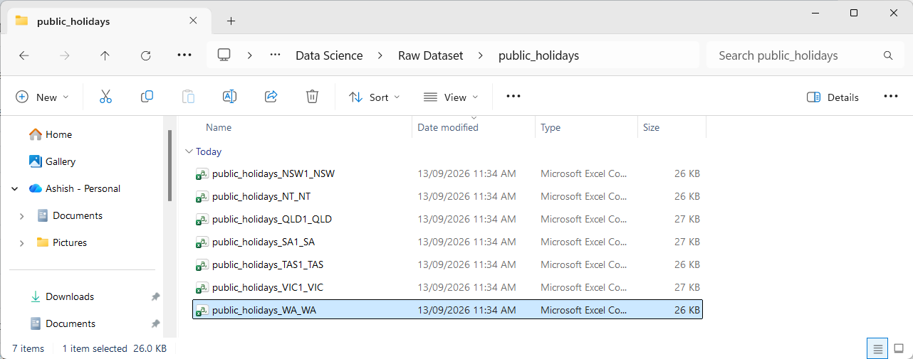
Figure 6. Public-holiday output files by region/state in the current acquisition run.

